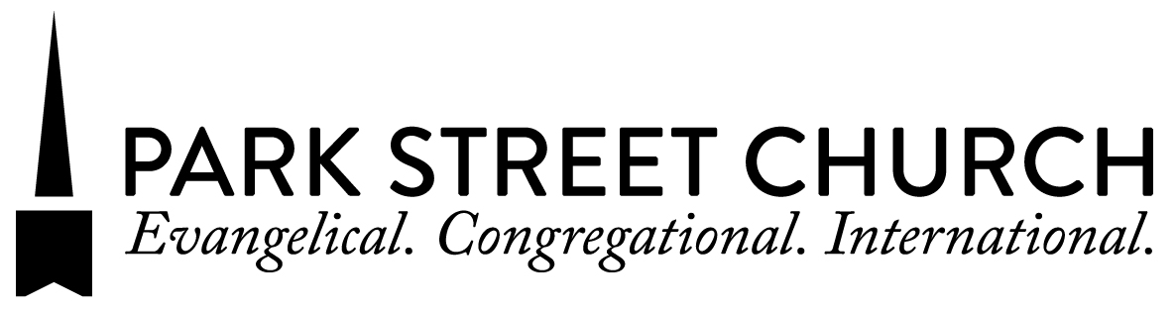
NEW MEMBER CLASS REGISTRATION QUESTIONNAIRE

Name:
Address:
City: Zip:
Phone Number:
Email:

- How long have you been attending Park Street Church?
- Which service(s) do you regularly attend? (Check all that apply.) 8:30am 11am 4pm

- Did you attend church before coming to Park Street Church? If yes, please tell us the name of your most recent church and what brings you here.

- Are you currently a member at a different church? YES NO If YES, please give us the church’s name and address, so that we may arrange a letter of transfer:
_________________________________________________________________________
Name Street City State ZIP

- When did you become a Christian? ___________________________
Briefly describe how you came to faith in Jesus Christ.

- Why do you want to make Park Street Church your spiritual home?

- Have you been baptized? YES NO
(If NO, please speak with your instructor to schedule a baptism by the end of your class.)

- Are you currently in a Park Street Church small group? YES NO

To register for the 7-week class, please circle the TIME of your first and second choices: (Please keep in mind that you must attend at least 6 of 7 classes to join.)
Sundays Jan 15 – Feb 26 9:30–10:45am 10–11:30am 5:30–6:45pm

Thursdays Jan 19 – Mar 2 7–8:30pm

Sundays Mar 12 – Apr 30 9:30–10:45am 10–11:30am 5:30–6:45pm

Return to: newmemberclass@parkstreet.org OR
Toni Kim, Minister of Membership * Park Street Church * One Park Street * Boston, MA 02108

